CMSC 411.05 Homework Assignment 2 Due: Oct 3, 2022, 2:29 pm

**Question 1** (10 points)

Convert the following C statements to equivalent MIPS assembly language. Assume that the variables f, g, h and j are assigned to registers $s0, $s1, $s2 and $s3 respectively. Assume that the base address of the array A and B are in registers $s6 and $s7 respectively.

a) f=g+h+B[5]

lw $t0, 20($s7)

add $s0, $s1, $s2

add $s0, $s0, $t0

b) f=g–A[B[3]]

lw $t0,12($s7)

sll $t1, $t0, 2

add $t2, $t1, $s6

lw $t3, 0($t2)

sub $s0, $s1, $t3

**Question 2 (10 points)**

Translate the following machine code to MIPS:

1010 11 10 000 0 1011 0000 0000 0000 0100

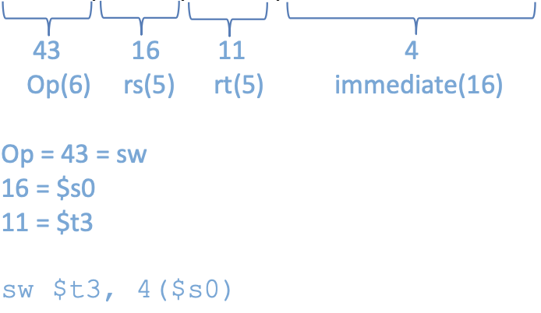

**Question 3 (10 points)**

Convert the following C fragment to equivalent MIPS assembly language. Assume that the variables a and b are assigned to registers $s0 and $s1 respectively. Assume that the base address of the array D is in register $s2.

while(a < 10){

D[a] = b + a;

a += 1;

}

Loop: stli $t0, $s0, 10

beq $t0, $zero, exit

sll $t1, $s0, 2

add $t1, $t1, $s2

add $t2, $s1, $s0

sw $t2, 0($t1)

addi $s0, $s0, 1

j Loop

exit:

**Question 4 (20 points, i.e. 2 points for each sub-task)**

Assume we are using the Big-Endian notation. Register $t0 contains 0x10000000 and $s0 contains 0x01234567. Suppose a portion of memory contains the following data

Address Data

0x10000000 0x12345678

0x10000004 0x9ABCDEF0

1. Complete the DATA column of following table

| Address | DATA |
| --- | --- |
| 0x10000000 | 0x12 |
| 0x10000001 | 0x34 |
| 0x10000002 | 0x56 |
| 0x10000003 | 0x78 |
| 0x10000004 | 0x9A |
| 0x10000005 | 0xBC |
| 0x10000006 | 0xDE |
| 0x10000007 | 0xF0 |

Show the effects on memory and registers of the following instructions. **Assume each of the following instructions is executed independently of the others, starting with the values given above.**

1. lw $t1, 0($t0)

$t1 = 0x12345678

1. lw $t2, 4($t0)

$t2 = 0x9ABCDEF0

1. lb $t3, 0($t0)

$t3 = 0x00000012

1. lb $t4, 4($t0)

$t4 = 0xFFFFFF9A → b is sign-extended

1. lb $t5, 3($t0)

$t5 = 0x00000078

1. lh $t6, 4($t0)

$t6 = 0XFFFF9ABC →lh is sign-extended

1. sw $s0, 0($t0)

at address 0x10000000 will contain 0x01234567

| Address | DATA |
| --- | --- |
| 0x10000000 | 0x01 |
| 0x10000001 | 0x23 |
| 0x10000002 | 0x45 |
| 0x10000003 | 0x67 |
| 0x10000004 | 0x9A |
| 0x10000005 | 0xBC |
| 0x10000006 | 0xDE |
| 0x10000007 | 0xF0 |

1. sb $s0, 4($t0)

| Address | DATA |
| --- | --- |
| 0x10000000 | 0x12 |
| 0x10000001 | 0x34 |
| 0x10000002 | 0x56 |
| 0x10000003 | 0x78 |
| 0x10000004 | 0x67 |
| 0x10000005 | 0xBC |
| 0x10000006 | 0xDE |
| 0x10000007 | 0xF0 |

1. sb $s0, 7($t0)

| Address | DATA |
| --- | --- |
| 0x10000000 | 0x12 |
| 0x10000001 | 0x34 |
| 0x10000002 | 0x56 |
| 0x10000003 | 0x78 |
| 0x10000004 | 0x9A |
| 0x10000005 | 0xBC |
| 0x10000006 | 0xDE |
| 0x10000007 | 0x67 |

**Question 5 (20 points)**

Convert the following program into machine. Note that first columns lists where these instructions are stored in the memory

| 0xFC00000C  0xFC000010  0xFC000014  0xFC000018  0xFC00001C | start:  loop: addi $t0,$t0,-1  sw $t0, 4($t2)  bne $t0, $t3, loop  j start |
| --- | --- |

Solution

